Asymmetrical Partners

Understanding China-Russia relations through data

*By Alessia Caruso and Tim Rühlig*

China does not want to see Russia being defeated on the battlefield in Ukraine. This is what Chinese Foreign Minister Wang Yi told the EU’s top diplomat Kaja Kallas when he visited Brussels in early-July. Indeed, Beijing has provided a lifeline – economically, militarily and diplomatically – to Moscow since the outbreak of the full-scale invasion in February 2022.

But China’s support is not limitless. Beijing has avoided paying a high economic and political price for its help, using Moscow as export hub, while minimising its dependencies on the partner.

How has Beijing supported Russia and where are its limits? The following 14 visuals provide the answer.

# Chapter 1: Growing trade

Since Russia’s full-scale invasion of Ukraine, China has become an economic lifeline for Moscow. This holds for both imports and exports.

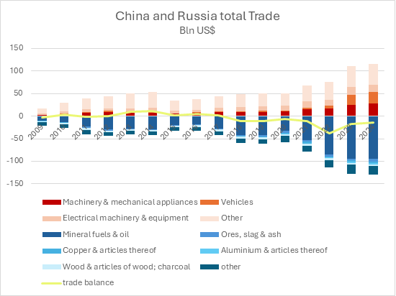   
(This graph will be interactive. [Click here for the full version](https://euisscloud-my.sharepoint.com/:w:/g/personal/alessia_caruso_iss_europa_eu/ESU9gsppwxJAvQ2NHRPgUlMByAarPIXPZfdtyPzcouvt3Q?e=NTZQkQ))

 Following Russia’s full-scale invasion of Ukraine in 2022, Chinese exports to Russia have soared, rising by over 50%—a sharp contrast to the post-Crimea period in 2014. The surge is especially pronounced in strategic sectors such as machinery and electrical equipment. With the exception of wood products, nearly all major trade categories have followed this upward trend, marking a notable shift in Beijing’s posture toward Russia’s aggression.

In the same period, Russia has become a useful export hub for China, particularly as European companies exited the market, leaving supply gaps across sectors. The auto industry is a striking example, with Chinese manufacturers rapidly expanding into the vacuum left by Western firms.

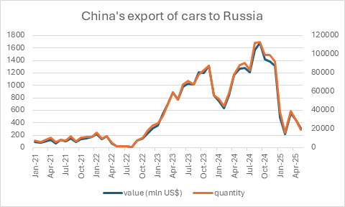

However, this growing reliance is not without frictions. China's overcapacity in sectors like manufacturing is putting downward pressure on Russian industry. In response, Russia has applied de facto tariffs on Chinese-made vehicles, a move that led to a marked and sustained decline in Chinese vehicle exports to Russia throughout 2025, indicating rising trade tensions between the two.



Chinese imports from Russia followed a similar trajectory, rising by 13% after the full-scale invasion of Ukraine in 2022. Since 2017, China has consistently imported more from Russia than it has exported, making Russia one of the few countries to maintain a positive trade balance with Beijing. Yet this surplus is narrowly based: a single category—mineral fuels—accounted for 38% of total trade in 2024 and 73% of all bilateral commerce.

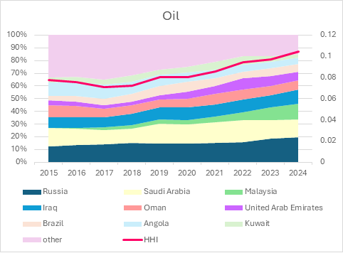   
(This is an interactive graph. [Click here to see the full version](https://euisscloud-my.sharepoint.com/:w:/g/personal/alessia_caruso_iss_europa_eu/EYmdEnB4AJtJpjHQ0bmaWEAB9cuzF1LTmvMCeDgmKWwZ1A?e=AegDxQ))

China’s growing mineral fuel imports have centred primarily on oil, with Russia’s share rising steadily over the past decade. By 2024, Russia accounted for 20% of China’s oil imports—its highest level of reliance on any Russian commodity. The diversification index (HHI) also rose over the past year, indicating increased exposure. Still, China maintains a medium-high level of diversification, suggesting that its oil trade with Russia does not yet amount to dependency.

Unlike oil, which is relatively easy to transport, gas largely relies on pipelines, helping to explain why China’s energy imports from Russia are primarily focused on oil. But there is more to China’s trade strategy than mere practicality: Beijing is hesitant to agree to building a new gas pipeline, named Power of Siberia 2, as it does not see a long-term demand for it. This indicates that for China trade with Russia is all about its own demand. Moreover, an increased import of coal and gas from Russia has been functional to China’s strategy of diversification, with a HHI dropping in both cases.

# Chapter 2: Growing asymmetrical dependencies

Despite consistent growth in both imports and exports in recent years, the Russia–China economic relationship remains deeply asymmetrical. Russia is becoming increasingly reliant on China across a widening range of product categories, while Beijing maintains minimal exposure to Russian inputs.

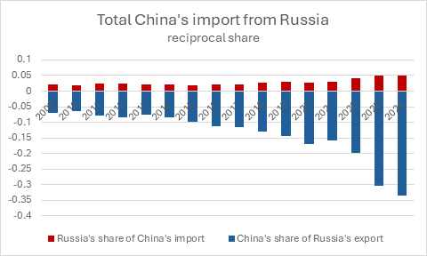

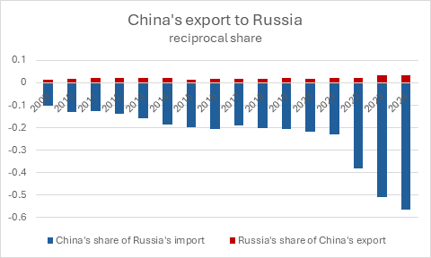

(This is a single graph and it’s interactive. [Click here to see the full version](https://euisscloud-my.sharepoint.com/:w:/g/personal/alessia_caruso_iss_europa_eu/EQYw4MNefotDuiqCLidGT9oBMbs1SlJ9PeOUO0LOeuWE_A?e=RTGZSh))

A comparison of trade shares across major sectors underscores this imbalance. Between 2022 and 2024, Russia’s dependence on Chinese goods surged: the share of Chinese products in Russia’s total imports jumped from 23% in 2021 to 57% in 2024. Over the same period, Russia’s importance as a supplier to China barely moved, with its share of China’s total imports increasing by less than one percentage point.

Russia’s exports to China show a similar picture: Even in mineral fuels—Russia’s most strategic export—the asymmetry holds. Russia’s share in China’s fuel imports rose by just 6 percentage points, while China’s role in Russia’s energy exports ballooned from 25% to 38%. In short, Russia is becoming ever more dependent on access to the Chinese market, while China’s exposure to Russian trade remains limited and highly concentrated.

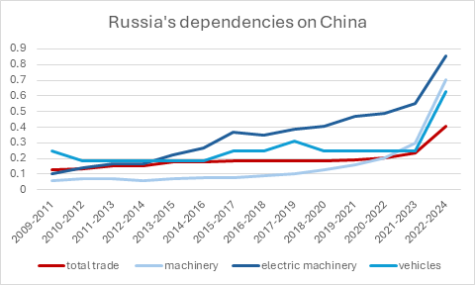

To assess Russia’s dependencies on China further, an analysis Russian imports across key product categories (at the 4-digit HS level) reveals significant dependencies. A product category is considered “dependent” if more than 30% of imports originate from China and if total imports are at least twice the value of exports—indicating limited domestic production capacity.

This methodology reveals a clear pattern of rising dependencies, particularly in strategic sectors such as machinery and electronic equipment. Applied in reverse, the asymmetry becomes even more apparent: China depends on Russia for less than 0.1% of its product categories.

The result is a pronounced dependency gap that translates into asymmetric strategic flexibility. Particularly, Beijing retains the option to dial back cooperation if the political or economic costs rise. Moscow, by contrast, has no such leverage: its reliance on Chinese goods renders it vulnerable to any shift in Beijing’s calculus. In short, while China can afford to recalibrate, Russia is locked in. This imbalance constrains Russia’s room for manoeuvre—and amplifies the secondary effects of any pressure applied to China.

# Chapter 3: Military ties

On the military front, China and Russia maintain long-standing defence ties. For decades, the two countries have carried out joint military exercises and trade military items.

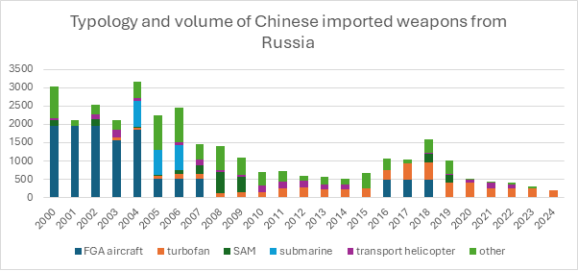

Yet, a clear shift is observable: China's arms imports from Russia are declining. The full-scale invasion has not reversed this trend.

But China’s reliance on Russian weapons is declining not only in volume but also in technological sophistication. In recent years, approximately 80% of China’s military imports from Russia have consisted of turbofan engines—complex systems produced by only a handful of countries, indicating a niche but persistent dependency. However, even in this area, China is primarily importing less advanced generations of turbofan engines, underscoring the narrowing scope of technological reliance.

The overall reduction in both quantity and complexity of arms imports—combined with the fact that remaining purchases are limited to areas where China still lacks critical technical know-how—underscores Beijing’s drive for greater self-sufficiency. This trend further reinforces the structural asymmetry in the relationship, with China progressively shedding its reliance on Russian military inputs.

# Chapter 4: Dual use goods

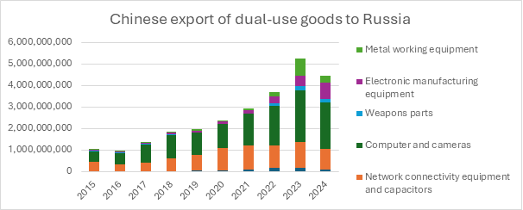Dual-use goods — civilian items with potential military applications, such as precision machinery, electronics, and navigation equipment — have become a central channel of China’s indirect military support to Russia.

Since the start of the full-scale war in 2022, Chinese exports of these goods to Russia have surged, exceeding USD 5 billion in 2023, with growth concentrated in computers and electronic manufacturing equipment. These flows have helped sustain Russia’s war effort while deepening Moscow’s reliance on Beijing.

Strikingly, however, there is indication that a significant share of these exports is not produced in China, but in Europe. To start with, China is far from self-sufficient in many of these strategic goods. In 2024, for more than one-third of dual-use product categories, the EU accounted for at least 30 % of China’s imports — worth over USD 57 billion.

For certain items, such as radionavigation systems and telescopic sights, over half of China’s imports originate from the EU. This creates a structural dependency: Beijing’s capacity to export such goods — including to Russia — partly depends on uninterrupted EU supply.

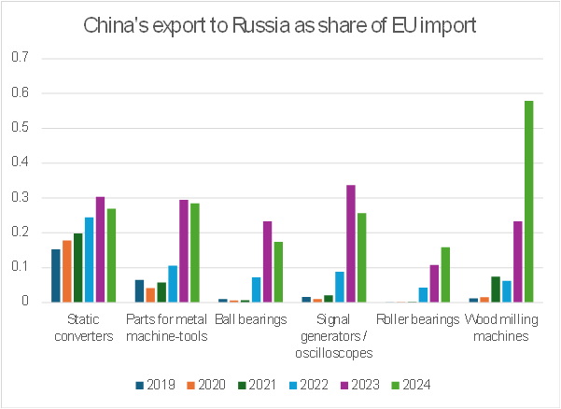

Another indication that a significant share of China’s dual-use item exports to Russia is a transshipment of European goods is the share of export volume to Russia as share of imports from the EU. Where China depends heavily on EU supply for a product, the risk that a significant share of those goods flows from China to Russia is real.

Analysis shows that for several categories, the share of China’s exports to Russia compared to its EU imports shifted sharply after 2022 — in some cases surpassing pre-war patterns by a wide margin. For example, in 2024, exports of wood milling machines to Russia amounted to nearly 60 % of China’s imports of the same category. For the same good, the EU represented more than half of the total import, implying a clear transhipment risk.

This pattern confirms that EU-origin goods entering China can indirectly reach Russia through re-export, especially in high-dependency categories. According to a classified paper of the German Federal Foreign Office seen by German media, the EU Sanction Envoy David O’Sullivan estimates that China (including Hong Kong) accounts for around 80% of the circumvention of EU export controls of dual-use items.

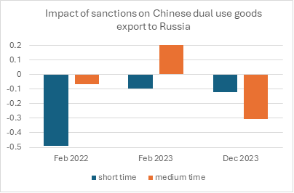

However, also in this case, China's support to Russia is responsive to external pressure. 2024 marked a turning point: for the first time since the full-scale war began, Chinese dual-use exports declined. The drop, sustained in the medium term, followed U.S. secondary sanctions on Chinese financial institutions, highlighting Beijing’s sensitivity to financial pressure and, notably, its willingness to recalibrate when external costs rise.

These dynamics carry clear strategic implications for the EU. In key dual-use categories, Brussels holds meaningful leverage over Beijing: restrictions on EU exports would compel China to prioritise its own domestic needs, indirectly limiting Russia’s access to critical goods. Evidence from recent U.S. measures demonstrates that targeted, well-calibrated sanctions can alter Chinese export behaviour, even in sectors with direct military relevance. A more coordinated EU approach — using China’s dependencies to apply pressure through precisely targeted export controls and secondary sanctions — could significantly disrupt Moscow’s access these critical dual-use goods.

European sanctions and export controls have faced implementation challenges, a more coordinated approach, particularly one leveraging Chinese dependencies through targeted secondary sanctions, could prove significantly more effective. Evidence suggests that Beijing is responsive to external economic pressures, indicating that well-calibrated measures may encourage a reassessment of its support to Russia.

# Chapter 4: Diplomatically alignment

China and Russia are often believed to maintain a shared narrative. Indeed, both promote a vision of a multipolar order in opposition to the Western-led system. However, this rhetorical alignment masks a less consistent reality on the diplomatic ground, particularly within international institutions like the United Nations.

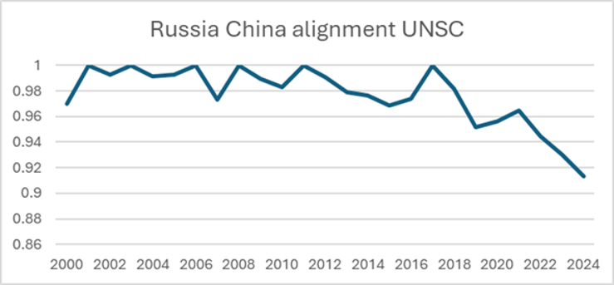

In the UN Security Council, both traditionally align quite well. Since 2021, however, their voting patterns show growing divergence. China has often displayed greater flexibility. The war in Ukraine has not reversed this trend.

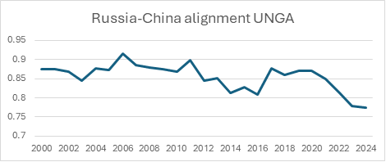

The alignment in the United Nations General Assembly have always been lower, but a similar trend is visible.

Unlike in trade patterns, both Russian aggressions against Ukraine in 2014 (Crimea, Donbass) and 2022 (fully-scale invasion) were followed by a decline in diplomatic alignment of China and Russia. This indicates the limits of Chinese support and a transactional element in Beijing’s policy. Every dimension of its relationship with Russia is calibrated to maximise strategic and economic gains. In the economic sphere, the war in Ukraine offers China clear advantages. At the UN, however, Beijing seems to be more careful and concerns of its self-image as a responsible global actor, making full alignment with Russia more difficult.

# Conclusions

The China–Russia relationship is solid but not immutable. China has become Russia’s primary economic lifeline, while at the same time becoming progressively more self-sufficient, thus shaping a highly asymmetrical dynamic. External pressures can and do have an impact in shaping the relation. This sensitivity is often underestimated. Recent developments show clearly that China is carefully considering negative implications for itself: the drop in dual-use exports after secondary sanctions, Russia’s retaliatory tariffs on Chinese vehicles, or the slowing alignment at the UN all indicate the limits of a friendship that both sides have called “unlimited”. These are not anomalies; they are signals of a relationship that is responsive to pressure and shaped by asymmetries.

This is not to deny the close partnership of Beijing and Moscow: China enables Russia’s war effort, but it does so when the price is low and the payoff high. The EU, as a major trading partner, has tools it has yet to fully leverage to increase the risks for China's support.

This analysis highlights three core takeaways:

1. The China–Russia relationship is real, strategic, but responsive—its strength should not be mistaken for inevitability. Despite talk of an “unlimited friendship,” China’s behaviour in the partnership is not purely driven by ideological considerations but has pragmatic elements. It remains sensitive to shifts in external pressure.
2. Their relationship is becoming increasingly asymmetrical—Russia grows more dependent, while its partner moves toward greater self-sufficiency. This imbalance grants Beijing strategic flexibility, while leaving Moscow tethered to Chinese supply lines.
3. The EU holds meaningful leverage that should be explored more, especially in the form of secondary sanctions.

The good news is: Beijing’s behaviour towards the Kremlin depends more on the price we make China pay than we might think. It is unrealistic to assume we could dismantle the China–Russia relationship. But increasing the price for Beijing could make it reduce its support. This, in turn, would have enormous consequences for Moscow that depends more and more on China.